GitHub Workflow Assignment

1. Create a New Repository

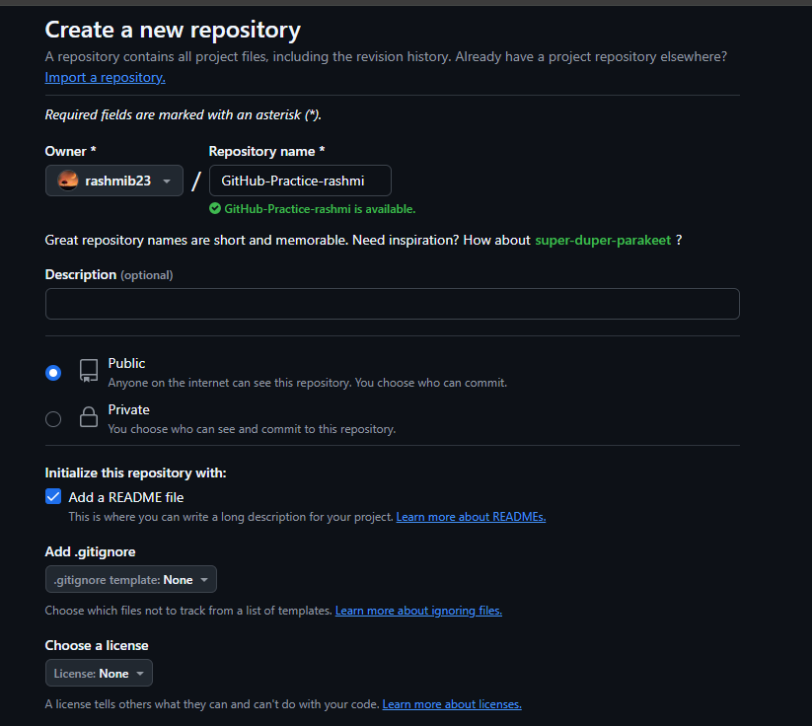

1. Clone the Repository to Your Local Machine

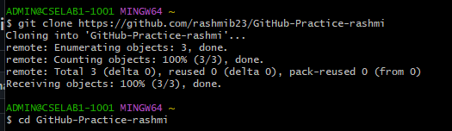

1. Create a New Branch

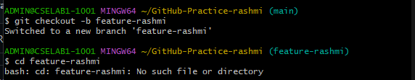

1. Add a New File and Make Changes

Create a text file named my_info.txt.

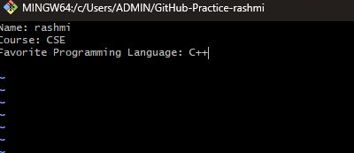

1. Stage and Commit the

Changes



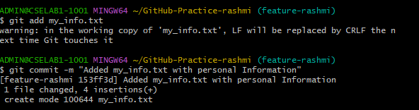

1. Push the Changes to GitHub

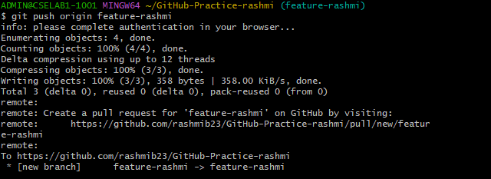

1. Create a Pull Request (PR)

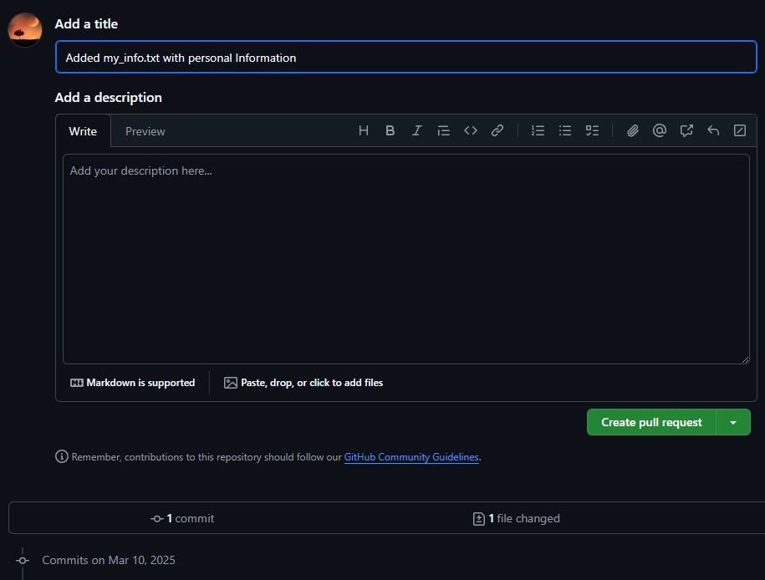

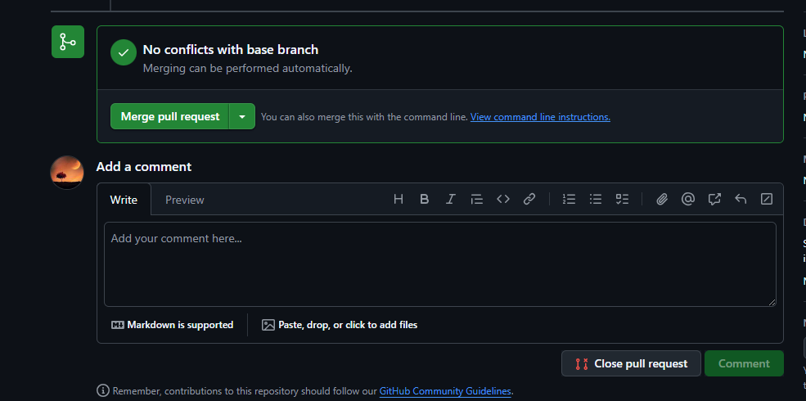

1. Merge the Pull Request

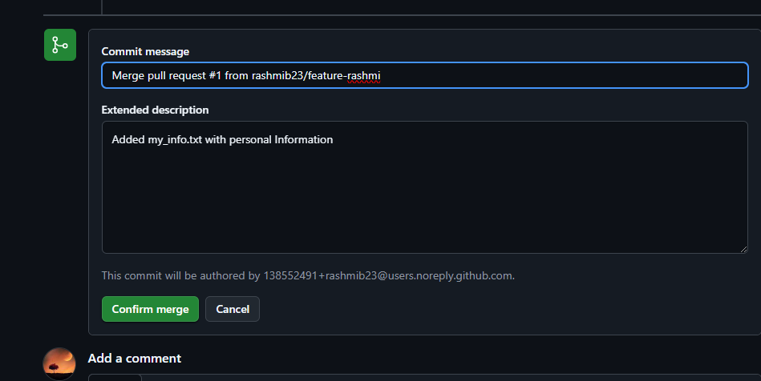

1. Pull the Updated Code to Local Machine

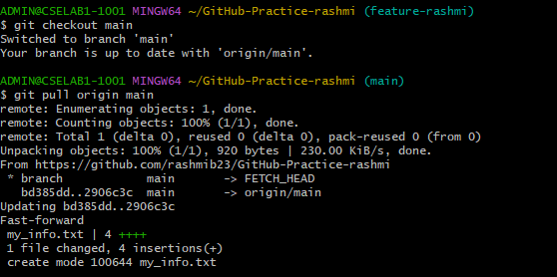

1. 10. Delete the Feature Branch (Optional, Best Practice)

git branch -d feature-rashmi

git push origin --delete feature-rashmi

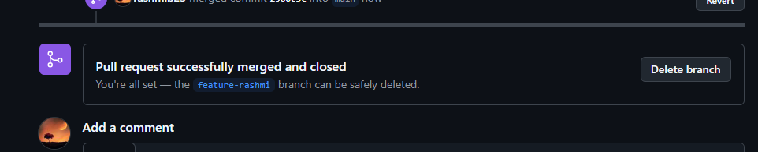

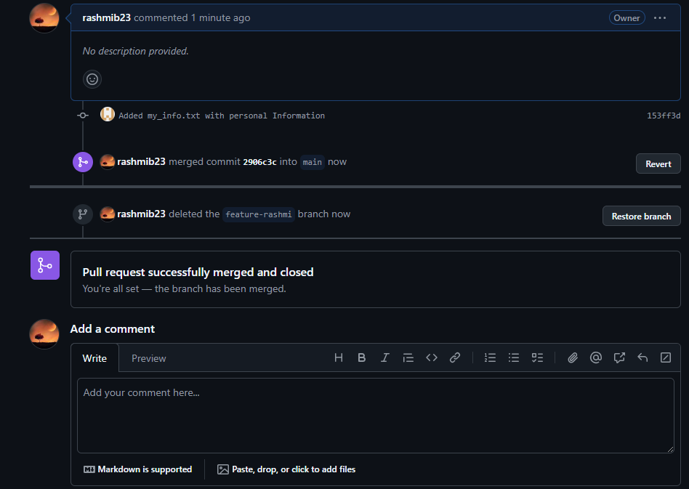

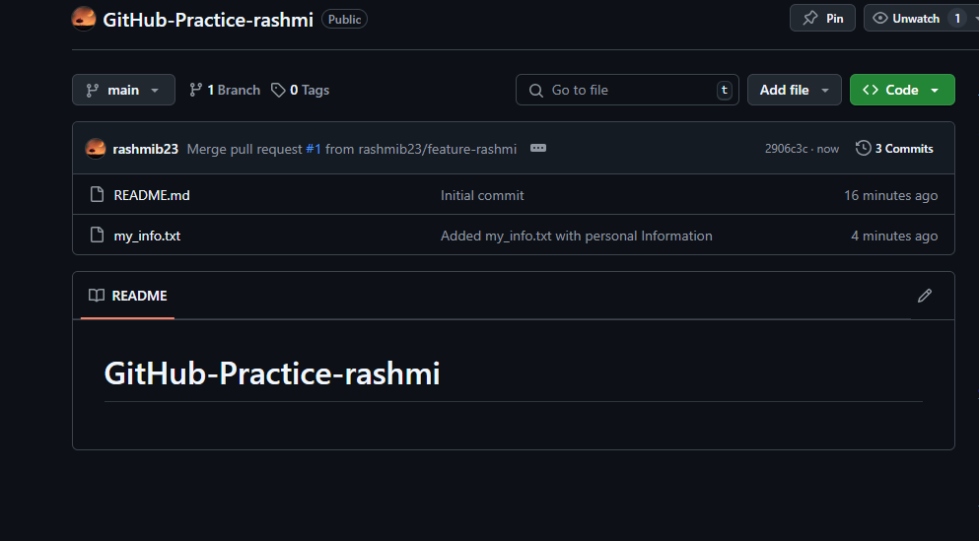

https://github.com/rashmib23/GitHub-Practice-rashmi